SMART AGRICULTURE USING IOT

1.1 INTRODUCTION

Smart Agriculture using the Internet of Things (IoT) is a modern farming approach that uses connected sensors, devices, and communication technologies to monitor and manage agricultural activities. IoT enables farmers to collect real-time data on soil, weather, crops, and livestock, helping them make informed decisions. This technology improves productivity, reduces resource wastage, and supports sustainable farming.
The main objective of smart agriculture is to make farming more efficient, accurate, and sustainable. In an IoT-based agricultural system, sensors are placed in the field to continuously monitor important parameters such as soil moisture, temperature, humidity, soil pH, water level, and environmental conditions. The data collected by these sensors is transmitted through communication networks to a cloud platform or control system for processing and analysis.
Based on the collected data, farmers can determine the appropriate time for irrigation, fertilization, and other agricultural activities. For example, when the soil moisture level falls below a predefined value, an automated irrigation system can turn on the water pump and supply the required amount of water. Once the desired moisture level is reached, the pump can be switched off automatically. This reduces unnecessary water consumption and minimizes manual effort.

1.2 NEED FOR SMART AGRICULTURE

Agriculture faces several challenges such as water scarcity, changing weather conditions, increasing labor costs, soil degradation, and low productivity. Traditional farming methods often require continuous manual monitoring and may result in the inefficient use of water, fertilizers, and other resources. Therefore, there is a need for smart and efficient farming techniques that can improve productivity while reducing resource wastage.
Smart Agriculture using IoT helps farmers monitor soil moisture, temperature, humidity, water levels, and other important conditions in real time. IoT-based systems can automate activities such as irrigation and provide alerts when field conditions require attention. This reduces human effort, saves resources, lowers farming costs, and helps farmers make better decisions, leading to more productive and sustainable agriculture.

1.3 SMART AGRICULTURE USING IOT

Smart Agriculture using the Internet of Things (IoT) is a modern farming method that uses sensors, smart devices, and communication technologies to monitor and manage agricultural activities. Sensors placed in the field can measure soil moisture, temperature, humidity, soil pH, water level, and other environmental conditions. The collected data is sent to a control system or cloud platform, where it can be analyzed and viewed by farmers through a mobile or web application.
IoT also helps automate important farming activities such as irrigation and environmental monitoring. For example, when the soil moisture becomes too low, an IoT-based system can automatically switch on the water pump and turn it off when sufficient moisture is reached. This reduces water wastage, saves time and labor, improves crop growth, and allows farmers to monitor their fields remotely. Thus, Smart Agriculture using IoT makes farming more efficient, productive, and sustainable.

1.4 COMPONENTS AND TECHNOLOGIES USED

Soil Moisture Sensor | Measures the moisture content in the soil and helps determine when irrigation is required.
Temperature & Humidity Sensor | Measures the surrounding temperature and humidity of the agricultural field.
Water Level Sensor | Monitors the amount of water available in the tank or reservoir.
Microcontroller (ESP32/Arduino) | Collects sensor data, processes it, and controls other devices.
Relay Module | Acts as an electronic switch to control the water pump.
Water Pump | Supplies water to the crops when irrigation is required.
Wi-Fi/GSM Module | Sends sensor data to a cloud platform or mobile application.
Power Supply | Provides the required electrical power to the sensors, controller, and other components.
Cloud/IoT Platform | Stores and displays collected data and enables remote monitoring.
Mobile/Web Application | Allows farmers to monitor field conditions and receive alerts remotely.

1.5 WORKING OF IOT BASED SMART AGRICULTURE

The smart agriculture system uses sensors to continuously monitor important field conditions such as soil moisture, temperature, humidity, and water level. These sensors send the collected data to the microcontroller, such as an ESP32 or Arduino. The controller processes the data and sends it to an IoT/cloud platform through a Wi-Fi or GSM connection. Farmers can view the field conditions remotely using a mobile or web application.
When the soil moisture level falls below a predefined value, the microcontroller activates the relay, which switches ON the water pump. The pump supplies water to the crops until the required moisture level is reached. The controller then switches OFF the pump automatically. This process helps save water, reduce manual effort, monitor crops in real time, and improve agricultural productivity.

1.6 BLOCK DIAGRAM
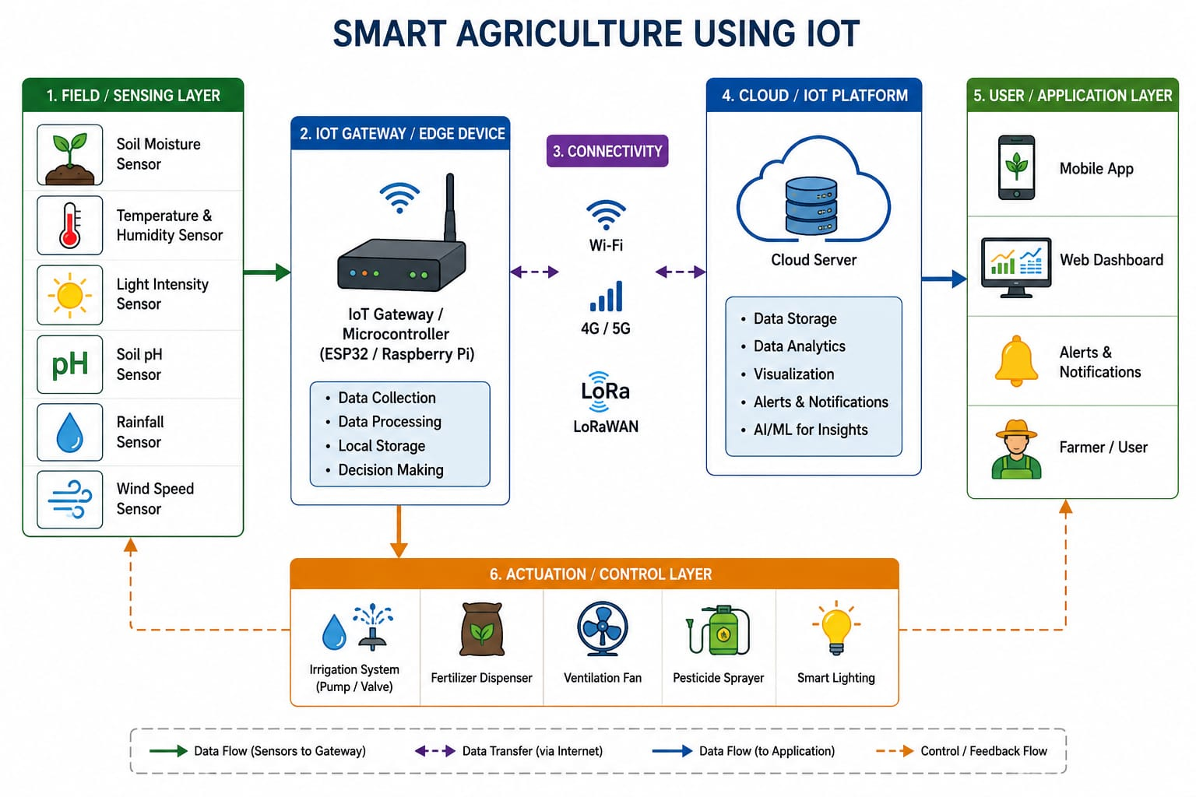

1.7 APPLICATION

- Smart Irrigation – Automatically controls water supply based on soil moisture.
- Crop Monitoring – Monitors crop growth and field conditions in real time.
- Weather Monitoring – Measures temperature, humidity, rainfall, and other weather conditions.
- Soil Monitoring – Checks soil moisture, temperature, pH, and nutrient conditions.
- Pest and Disease Detection – Helps identify crop diseases and pest attacks at an early stage.
- Greenhouse Automation – Automatically controls temperature, humidity, lighting, and irrigation.
- Livestock Monitoring – Tracks animal health, location, and activity using sensors.
- Remote Farm Management – Allows farmers to monitor and control farming equipment using a mobile or web application.

1.8 ADVANTAGES

- Saves Water – Provides water only when required by the crops.
- Increases Crop Productivity – Helps maintain suitable conditions for healthy crop growth.
- Reduces Labor – Automates irrigation and monitoring tasks.
- Saves Time and Cost – Reduces manual work and unnecessary use of resources.
- Real-Time Monitoring – Allows farmers to monitor field conditions continuously.
- Early Problem Detection – Helps identify soil, weather, pest, and crop-related problems quickly.
- Remote Control – Farmers can monitor and control equipment using a mobile or web application.
- Sustainable Farming – Promotes efficient use of water, fertilizers, and other natural resources.

1.9 CHALLENGES AND LIMITATIONS

- High Initial Cost – Sensors, IoT devices, communication systems, and installation can be expensive.
- Internet Connectivity – Remote agricultural areas may have poor or unreliable network connectivity.
- Maintenance – Sensors and electronic devices require regular maintenance and calibration.
- Technical Knowledge – Farmers may need training to operate and manage IoT-based systems.
- Power Requirements – IoT devices require a continuous or reliable power supply.
- Data Security – Collected farm data may face risks related to privacy and cybersecurity.
- Environmental Conditions – Sensors can be affected by rain, dust, heat, and other harsh field conditions.
- System Failure – Sensor or network failures can interrupt monitoring and automated operations.

1.10 CONCLUSION
Smart Agriculture using IoT is an effective approach to modernizing traditional farming practices. By using sensors, microcontrollers, communication networks, and automated systems, farmers can monitor soil and environmental conditions in real time and manage irrigation efficiently. This helps save water, reduce labor, lower costs, and improve crop productivity.
Although challenges such as high initial cost, internet connectivity, maintenance, and technical knowledge exist, IoT has great potential in agriculture. With further development of IoT, artificial intelligence, and automation, smart farming can become more efficient, sustainable, and reliable, contributing to the future of modern agriculture.

